**External Interface Requirement**

1. User Interface

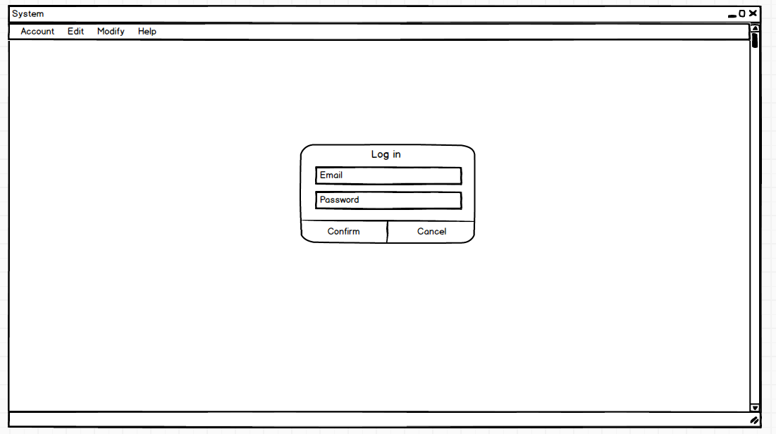

As users open the software, system will pop up a dialog box. Users could log in the system to view history or skip to the system without login.

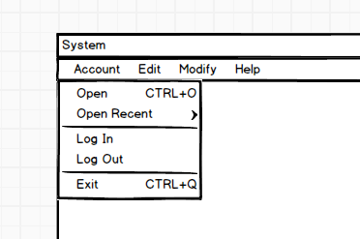

In the system, there are four main functions within the menu bar. The first one is Account function. Users could log in to their account and then they could open the image users saved before and users could open recent documents. In addition, users could log out to change an account or exit the system.

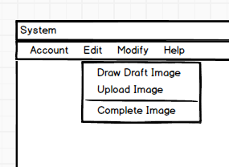

The second main function called Edit function. In this part, there are two method for users to input the source image. Users could upload a draft image from their computer. In addition, users could draw a source image by them self. By press draw draft image button, a painting function would pop up. There are a painting function tool bar including several paint tools like brush, colour and so on.

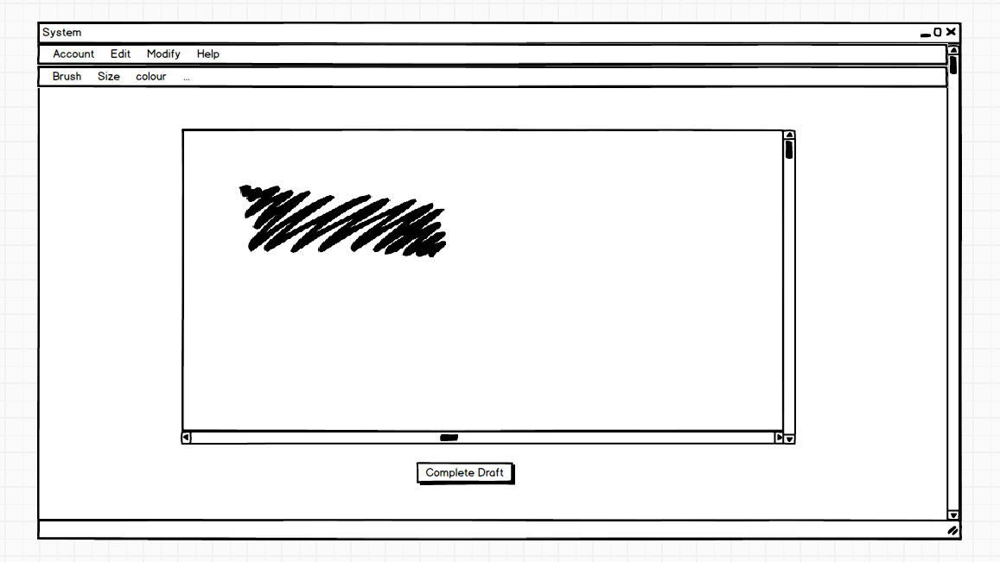

After draw a source picture, users could complete source image by pressing complete button.

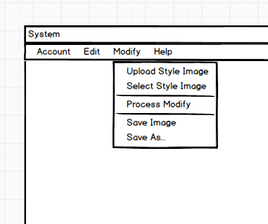

The third function called Modify to modify the source image to style image provided by users. There are two ways to offer a style image. First users could upload a style image to process modify by themselves. Or users could select a style image provided by system. There also a process modify button to start. In addition, users could save the processed image into different format.

System also provide a help function for users to understand how does the system work. And some of common used function like open function have shortcut key shown in the tool bar.

1. Hardware interface

Our system could run on windows 7 system and after or Mac OS 10.11 after. The system require at least 2.4 GHz inter Core i5 for processor and at least 4GB memory to ensure the style process rapidly and effectively.